**Hello Team!** **Consider the below two tables**:

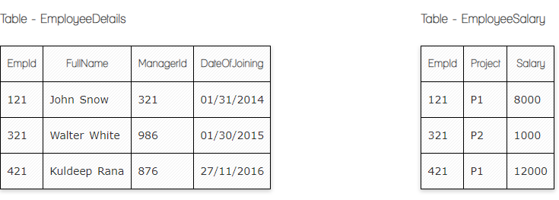

**Ques.1. Write a SQL query to fetch the count of employees working in project 'P1'.**

**Your Answer:**

**Select count (*)**

**From EmployeeSalary**

**Where EmployeeSalary.project=’p1’**

**Ques.2. Write a SQL query to fetch employee names having salary greater than or equal to 5000 and less than or equal 10000.**

**Your Answer:**

**Select EmployeeDetalis.FullName**

**From EmployeeDetalis inner join** **EmployeeSalary on Empid=Empid**

**Where EmployeeSalary.salary between 5000 and 10000**

**Ques.3. Write a SQL query to fetch count of employees sorted by project's count in descending order.**

**Your Answer:**

**Select count (*)**

**From EmployeeSalary**

**group by Project**

**Order by Project desc**

**Ques.4. Write a query to fetch employee names and salary records. Return employee details even if the salary record is not present for the employee.**

**Your Answer:**

**Select EmployeeDetalis.FullName, EmployeeSalary.Salary**

**From EmployeeDetalis Left join EmployeeSalary on Empid=Empid**

**Ques.5. Write a SQL query to create an empty table with ‘Test’ name.**

**Your Answer:**

**Create table Test (ID int);**

**Ques.6. Write a SQL query to delete an empty table with ‘Test’ name.**

**Your Answer:**

**Drop table Test;**

**Ques.7. Write a SQL query to fetch all the Employees details from EmployeeDetails table who joined in Year 2016.**

**Your Answer:**

**Select \***

**From EmployeeDetails**

**Where DateOfJoining between ‘01-01-2016’ and ‘31-12-2016’**

**OR**

**Select \***

**From EmployeeDetails**

**Where YEAR(DateOfJoining) = 2016**

**Ques.8. Write a SQL query to insert new record to the EmployeeDetails table with any data**

**Your Answer:**

**Insert into EmployeeDetails(EmpID, FullName, ManagerId, DateOfJoining)**

**Values(‘600’, ‘Test Test’,986,’01-01-2024’);**

**Ques.9. Write a SQL query to update EmployeeSalery table with setting Salary to 2000 for Project P2.**

**Your Answer:**

**Update EmployeeSalery Set Salary = 2000 where Project = ‘P2’**

**Ques.10. Write a SQL query to right join both tables and draw the results.**

**Your Answer:**

**Select \***

**From addresses right join users on addresses.user_id= users.id**

|  |  |  |  |  |  |  |  |
| --- | --- | --- | --- | --- | --- | --- | --- |
| **User_id** | **street** | **city** | **state** | **id** | **Full_name** | **enabled** | **Last_login** |
| **1** | **1 Market Street** | **San Francisco** | **CA** | **1** | **John Smith** | **f** | **2017-10-25 10:26:10.015152** |
| **2** | **2 Elm Street** | **San Francisco** | **CA** | **2** | **Alice Walker** | **t** | **2017-10-25 10:26:50. 295461** |
| **3** | **3 Main Street** | **Boston** | **MA** | **3** | **Harry Potter** | **t** | **2017-10-25 10:26:50.295461** |
| **null** | **null** | **null** | **null** | **5** | **Jane Smith** | **t** | **2017-10-25 10:36:43.324015** |

**Now take these two tables:**

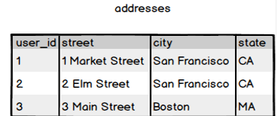

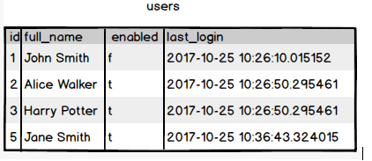

**Ques.11. Write a SQL query to fetch all users full_name from San Francisco.**

**Your Answer:**

**Select users.full_name**

**From users inner join addresses on users.id = addresses.user_id**

**Where addresses.city = ‘San Francisco’**

**Ques.12. Write a SQL query to fetch all users full_name, last_login who are enabled**

**Your Answer:**

**Select full_name, last_login**

**From users**

**Where enabled = ‘t’**

**Ques.13. Write a SQL query to fetch all users full_name who are not from Main street**

**Your Answer:**

**Select users.full_name**

**From users inner join addresses on users.id = addresses.user_id**

**Where NOT addresses.street = ‘Main street’**

**Ques.14. Write a SQL query to fetch all users full_name who are from Main street or San Francisco**

**Your Answer:**

**Select users.full_name**

**From users inner join addresses on users.id = addresses.user_id**

**Where addresses.street = ‘Main street’ OR addresses.city = ‘San Francisco’**

**Ques.15. Write a SQL query to fetch user full_name who is equal to user_id from Boston (find user_id value in sub_query)**

**Your Answer:**

**Select full_name**

**From users**

**Where id in (Select user_id**

**From addresses**

**Where city = ‘Boston’ )**